System Architecture

Team name
Project domain
Architecture chosen
Version | v1.0 — update when revised in response to feedback
This is a living document. Update the version number each time it is revised. The architecture documented here must remain consistent with the domain model (Portfolio Item 3) and the user story backlog (Portfolio Item 2).

Overview and Checklist
This portfolio item contains five sections developed across Weeks 4 and 5. Each section builds on the previous one and on the domain model produced in Portfolio Item 2.

✓ | Section |  | Content | Items | Connects to
□ | B | Item 4 | C4 context & container diagram | Diagram attachment + actor annotation table + container inventory table | Stakeholder map (Portfolio Item 1),  Bounded contexts (Portfolio Item 3)
□ | C |  | C4 component diagram | Diagram attachment + module interface table + cross-module communication summary | Bounded contexts + cross-boundary refs (Portfolio Item 3)
□ | D |  | Integration pattern summary | One row per significant integration | To-be BPMN (Portfolio Item 4); OpenAPI spec (Week 4)
□ | E | Item 5 | Two ADRs | ADR-01 integration, ADR-02 consistency | All portfolio items; user story IDs from Portfolio Item 1

Consistency check, run before submitting.
Every module or service in the C4 container and component diagrams must correspond to a bounded context in your domain model. Every cross-boundary reference annotated in the domain model worksheet must appear as an inter-module communication path in the component diagram. Every integration pattern in Section D must be documented in ADR-02 or have a reference to the ADR that covers it. If any of these checks fail, review your domain model and architecture together before submitting.

Context and Container diagram
Attach or embed your C4 Level 2 diagram below. Your system scope boundary (i.e., level 1 Context diagram) has to be correctly shown as part of your level 2 (Container) diagram. The context diagram shows the system as a single box, the people who interact with it, and the external systems it depends on or integrates with. It does not show internal structure.
The Container diagram shows the high-level technical building blocks (containers) and how they communicate. A container is anything that runs or stores data: a web application, a database, a message queue. Produce the diagram in draw.io. Use the correct shapes under C4 tab as discussed in class.

C4 context diagram minimum requirements.
The system shown as one named box with a brief description. All human actors from the Week 1 stakeholder map that interact with the system directly (not just affected by it). All external software systems the system calls or receives calls from (payment provider, governing body registration system if applicable). Arrows labelled with the nature of the interaction (e.g. 'renews membership online', 'processes payment via API'). Consistent C4 notation: Person shapes for people, System shapes for software systems.

The container diagram changes depending on your architecture choice.
Monolith: one web application container and one database container. Modular monolith: one web application container (with an internal note listing the modules) and one database container (with schema separation noted). Microservices: one container per service, each with its own database container; communication paths labelled with mechanism (REST, event bus, etc.). All variants: include the technology choice for each container (e.g. 'PostgreSQL database', 'Node.js web application').

Actor and external system annotation
Complete one row per actor or external system shown in the context diagram. Every element in the diagram must appear in this table. The stakeholder column links this diagram back to the Week 1 stakeholder map. (do not include stakeholders that are not in your diagram)

Name in diagram | Type | Stakeholder map reference | Interaction with system
Student | Person / External system | Low power, High interest | Registers an account, browses approved listings, saves listings, and receives notifications for new free items
Student Org | Person / External system | Low power, High Interest | Registers an organization account, submits listings for approval, and manages approved listings
System Admin | Person / External system | High power, low interest | Approves user registrations, approves listing submissions, and monitors platform activity
Push Notification Service | Person / External system | Technical dependency | Receives notification requests from the platform and delivers push notifications to students
 | Person / External system

Container inventory and architecture justification
List every container in the diagram and justify the architectural choice in the box below.

Container name | Type | Technology (optional) | Responsibility
Web Application | Web app / Database / Queue / Service | Node.js/Express | Hosts the main application and REST API. Contains three internal modules: Identity & Access, Listings, and Engagement. Handles user registration, listing creation, browsing approved listings, saved listings, notifications, and approval workflows
PostgreSQL Database | Web app / Database / Queue / Service | PostgreSQL | Stores application data using separate schema namespaces for identity_access, listings, and engagement
Push Notification system | Web app / Database / Queue / Service | Firebase Cloud Messaging | Delivers push notifications to students when approved listings become available.
Internal Event Bus | Web app / Database / Queue / Service | In-Process Event Bus | Enables asynchronous communication between modules using events such as UserRegistered, UserApproved, UserRejected, and NewListingPublished

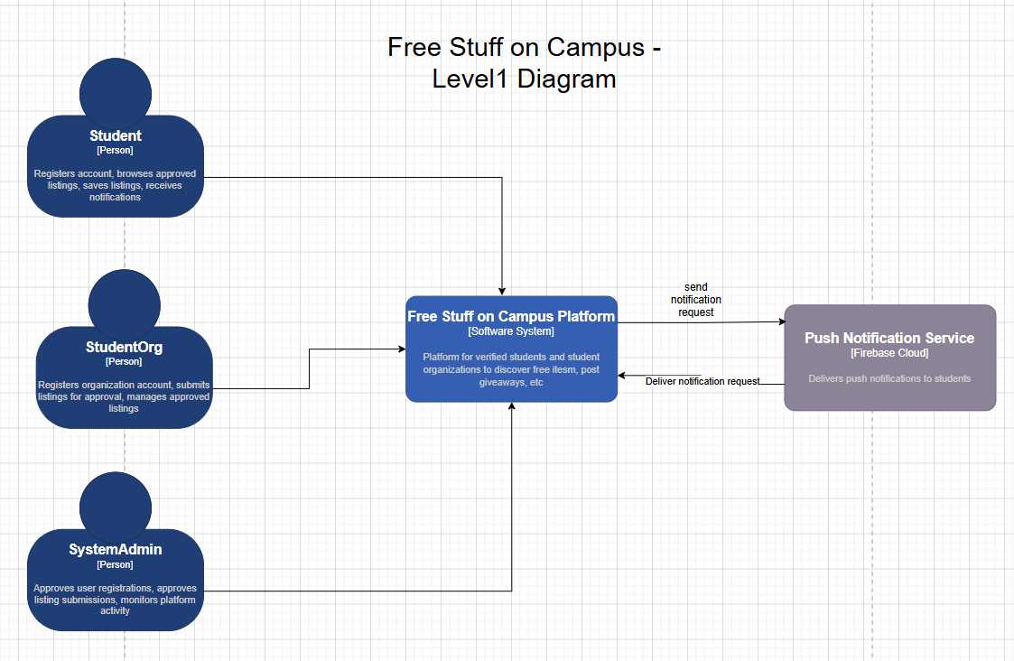

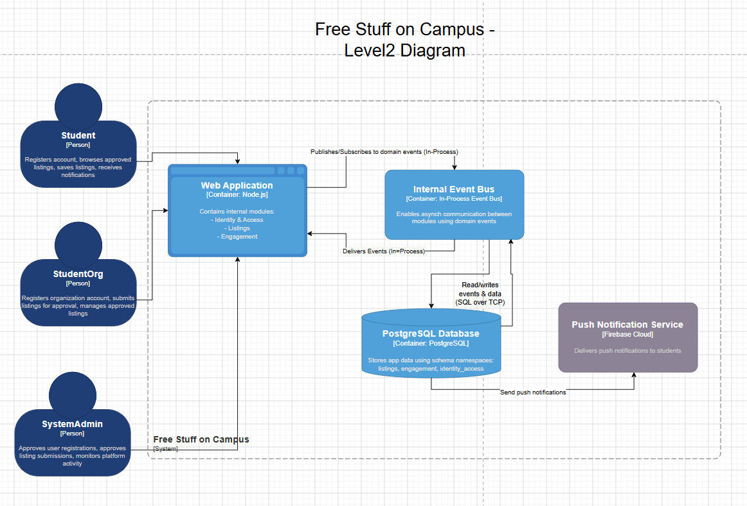

Component diagram
Attach or embed your C4 Level 3 component diagram for the primary container (the web application). This diagram shows the internal components (modules or services) and how they communicate with each other. For a modular monolith, this is the primary deliverable: it makes the bounded context structure and interface discipline visible.

Component diagram minimum requirements.
Each bounded context from the domain model appears as a named component with a type label [Module] or [Service]. Every inter-module or inter-service communication path is shown with an arrow labelled with:
- the nature of the call (e.g. 'get subscription status'),
- the mechanism (synchronous function/method call, async internal event, REST call, message queue). An internal event bus component is shown if used.
- The database is shown with schema separation annotated (e.g. membership.* schema, bookings.* schema).
- External systems that a module calls directly (e.g. payment provider) are shown as external components.

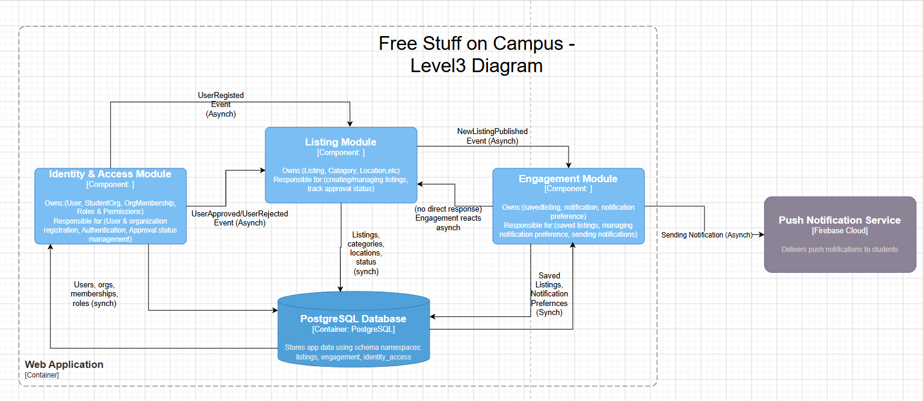

Module interface table
Complete one row per module or service shown in the component diagram. For each module, document the interface it exposes to other modules. The interface should describe what a module offers to other modules the named operations (e.g. getSubscriptionStatus, confirmBooking) and what they return. It should not describe internal database queries, internal functions, or implementation details. If the modular monolith is ever extracted to microservices, this interface becomes the API contract.

Module / service | Owns (data) | Interface operations exposed | Called by
Identity & Access | identity_access.* (User, StudentOrg, OrgMembership entities) | registerUser(request) → userId · getUserById(userId) → {userId, email, role} · verifyOrgStatus(orgId) → {status} · approveUser(userId) → {status} | Listings, Engagement, Client-facing API, System Admin
Listings | listings.* (Listing, Category, Location entities) | createListing(request) → listingId · submitListing(listingId) → {status} · getActiveListings(filters?) → Listing[] · getListingById(listingId) → Listing | Engagement, Client-facing API
Engagement | engagement.* (SavedListing, Notification entities) | saveListing(userId, listingId) → void · getSavedListings(userId) → Listing[] · createNotification(userId) → notificationId · getNotificationsForUser(userId) → Notification[] | Client-facing API, Listings

Cross-module communication summary
Complete one row per inter-module or inter-service communication path shown in the component diagram. This table must correspond exactly to the arrows on the diagram and to the cross-boundary references annotated in the annotated domain model (Portfolio Item 3).

Caller | Callee | Operation / event | Justification for this communication path
Listings | Identity & Access | verifyOrgStatus(orgId) [synchronous] | Before a listing is submitted, the system must verify that the organization is approved.
Identity & Access | Internal Event Bus | UserRegistered Event [ASYNC] | Registration events are published for later approval processing
Internal Event Bus | Listings | UserApproved/UserRejected Event [ASYNC] | Listing permissions depend on whether an organization has been approved.
Listings | Internal Event Bus | NewListingPublished Event [ASYNC] | When a listing is approved, an event is published so notifications can be generated.
Internal Event Bus | Engagement | Sending Notification Event [ASYNC] | Engagement receives notification events when new approved listings become available.
Engagement | Push Notification Service | sendNotification(notification) [WEBHOOK/API] | Sends push notifications to students about approved listings.

Integration pattern summary
Complete one row per significant integration in your system; both internal (module to module) and external (module to external system). All patterns must be one of the five covered in the Week 6 lecture. The pattern column must match what is shown in the component diagram (Section C). ADR-01 must justify the pattern chosen for at least the two most significant integrations.

Pattern | Abbreviation | Use when
Synchronous request-reply | SYNC | The caller needs an immediate answer to proceed. Fast, simple, creates temporal coupling.
Async message queue | QUEUE | The result is not needed immediately. Producer and consumer decouple in time. One consumer.
Event stream | STREAM | Multiple independent consumers need the same event. Replay required. Durable audit trail needed.
Webhook | WEBHOOK | An external system pushes notifications to your system on events it generates.
In-process event bus | INPROC | Modular monolith only. Async decoupling within a single process. Lighter than a message queue.

Integration pattern rationale.
The rationale should answer the three Week 6 decision questions:
- Does the caller need an immediate response?
- Does one consumer handle this or do multiple consumers react independently?
- Is this communication with an external system that pushes notifications?
A rationale that states only 'we chose X because it is simpler' has not applied the decision framework.

# | From (module/service) | To (module/service) | Pattern | Rationale; why this pattern for this integration?
1 | Listings | Identity & Access | Select: Synchronous request-reply / Async message queue / Event stream / Webhook / In-process event bus | Does the caller need an immediate response? Yes. The Listings module must immediately verify that the organization is approved before allowing a listing to be submitted. One consumer? Yes. Pattern: SYNC.
2 | Identity & Access | Internal Event Bus | Select: Synchronous request-reply / Async message queue / Event stream / Webhook / In-process event bus | Does the caller need an immediate response? No. User registration approval happens later and does not block the registration request. One consumer handles the event. Pattern: INPROC.
3 | Internal Event Bus | Listings | Select: Synchronous request-reply / Async message queue / Event stream / Webhook / In-process event bus | Does the caller need an immediate response? No. The Listings module can react after an approval decision is made. One consumer? Yes. Pattern: INPROC.
4 | Listings | Internal Event Bus | Select: Synchronous request-reply / Async message queue / Event stream / Webhook / In-process event bus | Does the caller need an immediate response? No. Notification generation can occur after a listing has been approved and published. Pattern: INPROC
5 | Internal Event Bus | Engagement | Select: Synchronous request-reply / Async message queue / Event stream / Webhook / In-process event bus | Does the caller need an immediate response? No. Engagement independently reacts to new listing events and generates notifications. Pattern: INPROC.
6 | Engagement | Push Notification Service | Select: Synchronous request-reply / Async message queue / Event stream / Webhook / In-process event bus | Is this communication with an external system that pushes notifications? Yes. The Engagement module sends outbound notification requests to Firebase Cloud Messaging. Immediate confirmation is not required. Pattern: WEBHOOK.
7
8

Architecture Decision Records (ADR)
Two Architecture Decision Records are required. Each captures a significant, hard-to-reverse decision. Complete all fields. The consequences section is the most analytically important part of an ADR, and the most commonly underdeveloped. Positive consequences that list only benefits and negative consequences that list 'none' are not honest. Every architectural decision makes something harder. Name it. An ADR that cannot identify any negative consequences has not been thought through seriously.
Empty consequences sections or alternatives without rejection reasoning will not receive credit.

ADR | Decision area | Guidance
ADR-01 | Primary integration pattern | Choose the integration pattern for the most significant inter-module or inter-service communication in your system. Apply the three decision questions. Alternatives must include at least synchronous and asynchronous options. Reference the specific integration (e.g. 'booking confirmation to notification module').
ADR-02 | Data consistency approach | Document how data consistency across module or service boundaries is maintained. For a modular monolith: how schema separation is enforced and when cross-schema transactions are permitted. For microservices: acknowledge eventual consistency, name the operations most at risk, and specify which pattern (saga, outbox, or compensating approach) would be used. Alternatives must include at least one distributed approach and one simpler approach.

ADR-1: Primary integration pattern

ADR-1
Title | Use synchronous validation and asynchronous event-driven workflows
Status | Proposed Accepted Superseded choose one
Context | The system is built as a modular monolith with three main modules: Identity & Access, Listings, and Engagement. Some actions require an immediate response before the process can continue. For example, the Listings module must verify that an organization is approved before allowing a listing to be submitted. However, user approvals, listing approvals, and notifications happen after administrator review and do not require an immediate response. These workflows are handled through the Internal Event Bus.
Decision | The system will use synchronous request-reply communication when immediate validation is required and asynchronous event-driven communication for approval workflows and notifications.
Alternatives considered | Complete one row per alternative. At least two alternatives are required.
Alt. 1 | Option: Synchronous request-reply communication for all module interactions.  Rejected because: approval workflows and notifications do not require immediate responses and would create unnecessary coupling between modules.
Alt. 2 | Option: External message queue (RabbitMQ/Redis).  Rejected because: the system is relatively small and does not require separate messaging infrastructure.
Alt. 3 | Option: Direct database access between modules.  Rejected because: modules should communicate through interfaces and events rather than directly modifying another module's schema.
Positive consequences | - Immediate validation is available when needed.  - Approval workflows are separated from user-facing requests.  - Notifications can be processed independently.  - Module boundaries remain clearly defined.
Negative consequences | - Event-driven workflows are more difficult to debug.  - Additional logic is required for event handling.  - Notifications may not be delivered instantly.
Traces to | US-01, US-02, US-05, US-09

ADR-2: Data consistency approach

ADR-2:
Title | Manage data consistency using schema separation in a shared PostgreSQL database
Status | Proposed Accepted Superseded choose one
Context | Describe the situation: The system uses a modular monolith architecture with a single PostgreSQL database. Data is separated into three schema namespaces: identity_access., listings., and engagement.*. The platform needs strong consistency when verifying organizations, managing approval statuses, creating listings, saving listings, and generating notifications. Although asynchronous events are used for approval workflows and notifications, all data remains within a shared PostgreSQL database and can be managed through ACID transactions.
Decision | Each module will own its own schema namespace and will only write to tables inside that schema. Modules will communicate through interfaces rather than directly modifying another module’s schema. Local PostgreSQL transactions will be used whenever strong consistency is required.
Alternatives considered | Complete one row per alternative. At least two alternatives are required.
Alt. 1 | Option: Eventual consistency using the saga pattern.  Rejected because: saga patterns are more appropriate for distributed microservices systems with multiple databases, which this project does not use.
Alt. 2 | Option: Outbox pattern for cross-module events.  Rejected because: the project does not rely heavily on asynchronous event processing, so adding an outbox pattern would create unnecessary complexity.
Alt. 3 | Option: Shared unrestricted database access between modules.  Rejected because: allowing modules to freely modify each other’s schemas would weaken boundaries between modules and increase coupling.
Positive consequences | 1. PostgreSQL ACID transactions provide strong consistency across the system.  2. Schema separation helps keep module responsibilities organized and easier to maintain.  3. Easier to implement and debug than distributed consistency approaches.
Negative consequences | 1. The PostgreSQL database becomes a single point of failure.  2. This approach would be harder to scale if the system later moved to independent microservices.
Traces to | US-01, US-02, US-05, US-09

Assessment Rubric
Sections B and C (including the C4 diagrams) are collectively weighted at 10% of the overall course. Section C (the ADRs) are collectively weighted at 6% of the overall course.

Criterion | Description | Distinction | Credit | Pass / Rework
C4 context diagram | System boundary correctly drawn. All external actors from the stakeholder map represented. External systems (payment provider, governing body) included. Notation consistent with C4 conventions. | All actors present and correctly typed. External systems named with communication mechanism annotated. Fully consistent with stakeholder map. | All actors present. Minor external system omissions. Notation mostly correct. | Key actors missing. External systems absent. Notation inconsistent or incorrect.
C4 container diagram | Architecture choice clearly reflected. Containers correctly identified for the chosen pattern. Communication paths labelled with mechanism. Database containers present with ownership noted. | Container diagram precisely reflects the chosen architectural pattern. All inter-container communication paths labelled. Database structure reflects domain model. | Correct pattern reflected. Most communication paths present. Minor labelling gaps. | Architecture not clearly reflected. Containers generic or incorrect. Communication paths unlabelled.
C4 component diagram | Internal module structure shown for the primary container. Each bounded context is a named component. Module interfaces labelled. Cross-module communication paths show mechanism (sync/async). Corresponds to (annotated ERD) domain model bounded contexts. | All bounded contexts present as named components with interface descriptions. Every cross-module communication path labelled with mechanism. Direct correspondence to annotated ERD domain model. | Most bounded contexts present. Some interfaces labelled. Cross-module paths mostly shown. | Components generic or missing. No interface labelling. No correspondence to domain model.
Integration pattern summary | All significant inter-module or inter-service integrations listed. Pattern selected for each with explicit rationale referencing the Week 6 decision framework. At least one asynchronous pattern present. Patterns consistent with component diagram. | All significant integrations listed. Pattern selection justified with the three decision questions. Patterns match component diagram. | Most integrations listed. Patterns selected but rationale brief. Minor inconsistencies with component diagram. | Integrations missing or incomplete. Patterns selected without rationale. Inconsistent with component diagram.
ADR quality | Each ADR has a clear decision statement, at least two alternatives considered with explicit rejection reasoning, and separate lists of positive and negative consequences. ADR-1 integration pattern, ADR-2 data consistency. All trace to user stories or portfolio items. | Both ADRs complete with defensible alternatives and honest consequences. Negative consequences explicitly named. Each ADR traceable to specific user stories. | Both ADRs present. Most alternatives have rejection reasoning. Consequences present but may be one-sided. | Less than two ADRs. Alternatives listed without rejection reasoning. Consequences absent or only positive.

Connection to Week 7
The component diagram in Section C is the primary input to the Week 7 security and privacy review. Each module interface is a potential attack surface. The Safeguarding module interface, which exposes junior member records, has fundamentally different access control requirements from the Bookings module interface. Before starting the OWASP review, review your component diagram and identify which module interfaces handle sensitive or restricted data; those are the highest-priority items for the security checklist.

Revision Log
Version | Date | Revised by | What changed and why
v1.0 |  |  | Initial submission

